ESC Activity in Service R

European Solidarity Corps volunteering
Personal data :
By filling the information below, you provide us with personal information. You are aware of the fact and agree that the pieces of information will be used in the frame of the call for candidates for the Erasmus+ volunteering project. Your personal data will be used by the persons in charge of the selection of volunteers in the sending and coordinating/hosting organizations. Each part mentioned takes the responsibility of erasing the documents containing your personal data once the selection procedure is over.

Name and surname
Birthdate
Current address
Phone number
Email address
Availability period for the project
(preference will be given to the volunteers able to join the project from beginning of February 2019 for 12 months)

Have you ever taken part in a volunteering project under ERASMUS+?
!!!VERY IMPORTANT!!!  Sending organization  (Name, Accreditation or PIC number, post address, phone number, contact person’s name and email address) | ProAtlântico-Associação Juvenil, 2014-1-PT02-KA110-00481, Casa Europa – Rua Policarpo Anjos nº43,1495-207 Cruz Quebrada, Portugal, Isa Correia – sveenvio@proatlantico.com
What are your (long term) travel experiences?
ESC PASS REFERENCE NUMBER
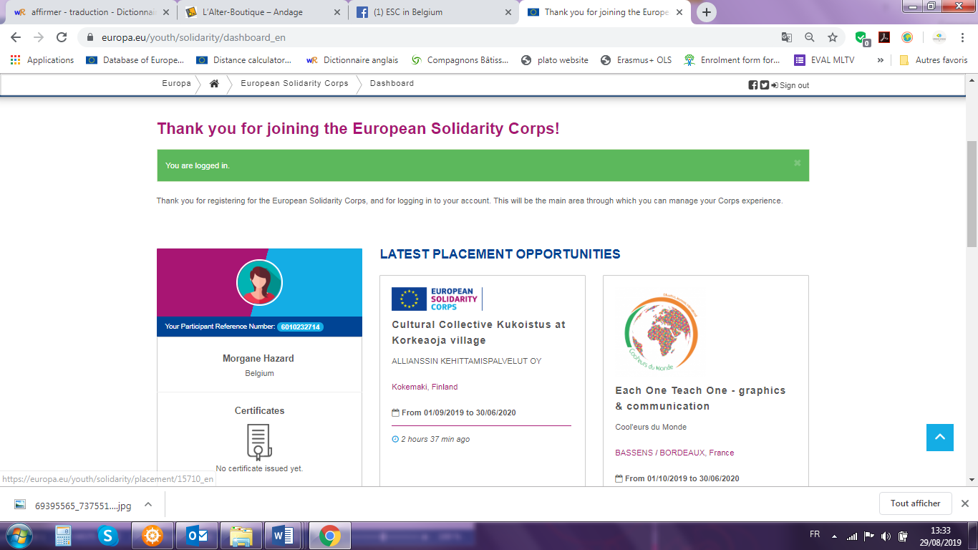

Fill in this questionnaire in FRENCH or in ENGLISH

- According to you what is the role of a service as the hosting organization?

- What are your motivation to take part in this project?

- How do you see your role, as volunteer, within these activities?

- Which are your qualities and weaknesses for this project?

- Do you think you will be confronted with some difficulties? If yes, which ones? If no, why?

- Do you have some special practical skills you would want to share during your project?

- Do you feel at ease with people with mental disabilities?

- Case 1: In the first days of the project, if a beneficiary is asking you something but you do not understand because of his difficulties to express himself added to the linguistic barrier, what would you do?

- Case 2: A beneficiary shares a personal request to you: s/he would like to experiment having a lunch out with another person with mental disabilities. How are you going to manage it?

- What would like to know about our organization and activities? Do you have any questions before to accept to be volunteer in our project?

- What do you like to do in your free time? What do you think about living in a semi-rural town?

THANK YOU VERY MUCH FOR HAVING FILLED THIS QUESTIONNAIRE IN
WE WILL CONTACT YOU AFTER THE DEADLINE TO GIVE YOU OUR FEEDBACK!

